**TITLE OF LAB: (SORTING ALGORITHMS PART A)**

**LAB REPORT NO.02**



**Spring 2022**

**CSE-210L Data Structures and Algorithm Lab**

Submitted by

Name:: **Safi Ullah Khan**

Registration No. **20PWCSE1943**

Class Section:

“On my honor, as student of University of Engineering and Technology, I have neither given nor received unauthorized assistance on this academic work.”

Student Signature: ______________

Submitted to:

**Dr. Khurram Shehzad Khattak**

(Friday, July 29th, 2022)

**Department of Computer Systems Engineering**

**University of Engineering and Technology, Peshawar**

**OBJECTIVES OF THE LAB**

‐‐‐‐‐‐‐‐‐‐‐‐‐‐‐‐‐‐‐‐‐‐‐‐‐‐‐‐‐‐‐‐‐‐‐‐‐‐‐‐‐‐‐‐‐‐‐‐‐‐‐‐‐‐‐‐‐‐‐‐‐‐‐‐‐‐‐‐‐‐‐‐‐‐‐

In this lab, we will learn about some basic sorting techniques and algorithms.

* Selection Sort
* Bubble Sort
* Insertion Sort

‐‐‐‐‐‐‐‐‐‐‐‐‐‐‐‐‐‐‐‐‐‐‐‐‐‐‐‐‐‐‐‐‐‐‐‐‐‐‐‐‐‐‐‐‐‐‐‐‐‐‐‐‐‐‐‐‐‐‐‐‐‐‐‐‐‐‐‐‐‐‐‐‐‐‐

## **Task 01**

Implement Selection Sort and analyze its worst, best and average case complexity.

**Screenshot of Input:**

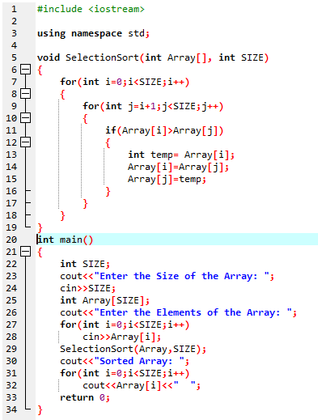

**Screenshot of Output:**

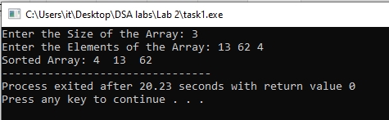

**Complexity:**

**Best case/Worst case:**

For selection sort algorithm both best case and worst-case complexity is O [N2] since in this algorithm there are two for loops and both for loops goes from 0 to n even if the array is already sorted.

## **Task 02**

Implement Bubble Sort and analyze its worst, best and average case complexity.

**Screenshot of Input:**

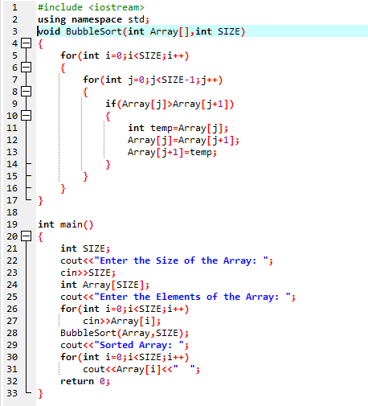

**Screenshot of Output:**

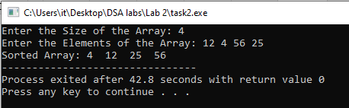

**Complexity:**

**Best case:**

For bubble sort algorithm best case complexity is O [N] since in this algorithm there are two for loops and in the best case where the array is already sorted the loop traverses only one time from 0 to n.

**Worst case:**

For bubble sort algorithm worst case complexity is O [N2] since in this algorithm there are two for loops and in the worst case where the array is mixed up, the loops traverses n time from 0 to n.

## **Task 03**

Implement Insertion Sort and analyze its worst, best and average case complexity.

**Screenshot of Input:**

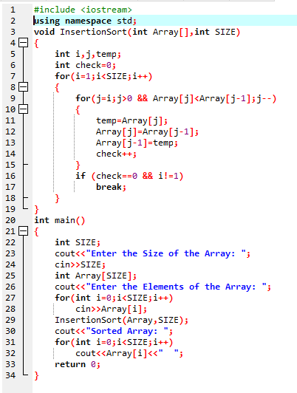

**Screenshot of Output:**

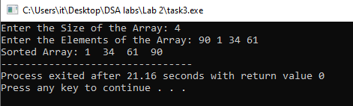

**Complexity:**

**Best case:**

For insertion sort algorithm best case complexity is O [N] since in this algorithm there are two for loops and in the best case where the array is already sorted the loop traverses only one time from 0 to n.

**Worst case:**

For insertion sort algorithm worst case complexity is O [N2] since in this algorithm there are two for loops and in the worst case where the array is mixed up, the loops traverses n time from 0 to n.